Media release: 6 June 2023

**World Gin Day:**

**Local companies raise a glass to new business opportunities**

Ahead of World Gin Day (Saturday 10 June), two Lake District tourism businesses say the popularity of the nation’s favourite tipple is creating new business opportunities here in Cumbria.

To co-incide with the global celebration of the juniper-inspired drink, Ravenglass and Eskdale Railway is launching the first of its brand-new [**‘gin trains**’](https://ravenglass-railway.co.uk/events/gin-train-with-local-distillery-shed-1-gin) this Friday 9 June.

It follows the popularity of [**gin tasting cruises**](https://www.ullswater-steamers.co.uk/events/gin-cruise) on sister-company Ullswater ‘Steamers’, which are also back on an extended, regular basis with weekly evening sailings every Friday between now and 21 July.

The new two hour gin train will depart from Ravenglass station for a scenic return journey to Dalegarth station to meet Ulverston’s Shed 1 distillery team, where passengers will find out more about the distilling process and sample some of their award-winning gins.

Meanwhile, Ullswater Steamers has teamed up with Chestnut House in Pooley Bridge, which is famous for the largest wall of gin in the Northwest. Passengers cruising the length of Ullswater onboard a heritage ‘Steamer’ will be entertained by local singer Fiona Hanlon as they sample complex botanical flavours. They can also bring their own picnic food on board.

Both attractions are operated by the family-run Lake District Estates. Its Head of Marketing and Business Development, Rachel Bell, says: *“The popularity of artisan craft gins shows no sign of slowing down. So with some leading distilleries on our doorstep, we recognised there was an opportunity to further develop gin-based experiences not only to attract new types of visitor but also to work together with other local businesses to support the wider economy.*

*“With World Gin Day just around the corner and some fantastic weather forecast for the coming weeks, what better time to raise a glass to this versatile tipple!”*

Darren Todd from Chestnut House, says: “*The gin cruises allow us to reach different, and often younger audiences. They also raise awareness about the shop - and we’ve actually already seen passengers popping back to view our full selection after taking part.*

*“It’s great to be working not just with Ullswater Steamers, but also a range of local distilleries and giving them a new way to market themselves to potential customers.”*

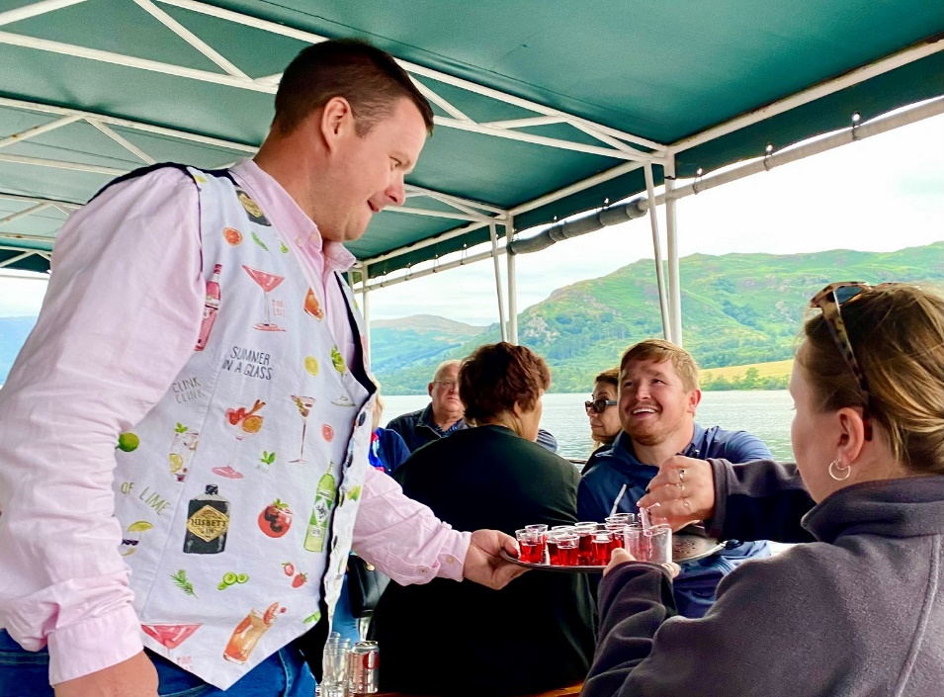 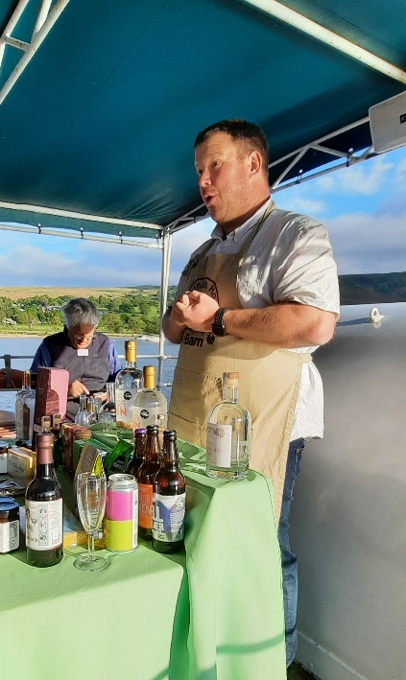

* **Evening ‘gin cruises’ depart** from Pooley Bridge aboard Ullswater ‘Steamers’

every Friday until 21 July. [**Book here**](https://www.ullswater-steamers.co.uk/events/gin-cruise).

* **Evening gin trains** will run on Ravenglass and Eskdale Railway on Friday 9 June and Friday 15 September. [**Book here**](https://ravenglass-ravenglass.b2c.lakedistrict.ticknovate.com/ticket/event/Ravenglass_Gin_Train).

ENDS

Notes to Editors:

**Hi res images attached – Darren Todd, Chestnut House with passengers on board a gin tasting cruise.**

For further information and media enquiries, please contact:

Heather Sewell, [hsewell@cumbriatourism.org](mailto:hsewell@cumbriatourism.org) / 07795 487003.